

**School of Engineering & Technology**

**Asian Institute of Technology**

**AT82.02 - Data Modeling and Management**



**Date: 5 October 2022**

**Lab Report: 6**

**Submitted To Submitted By:**

**Dr. Chutiporn Anutariya** [Todsavad Tangtortan](mailto:st123012@ait.ac.th)

**Lab06: Document Model (MongoDB)**

**Objective:** To study and practice the MongoDB commands to support data operations and queries.

**Estimated Time:** 1.5 hours

**Number of Tasks:**

**Due:** Friday 7 October 2022, 11:55 P.M.

**Scenario: TickTock E-Commerce**

This take-home assignment will use the same scenario as the in-class, ***TickTock E-Commerce system***. You are required to show how you design the document model schema and the appropriate commands for data operations and queries.

**Task 1:** Consider these two product items, and show how you design your documents for these two products in the JSON format.

**Product 1**

Source:

<https://www.amazon.com/OUTFINE-Executive-Computer-Ergonomic-Upholstered/dp/B09M6D6YS8/ref=sr_1_6?crid=SR2M1SO7Q74N&keywords=office%2Bchair&qid=1663909914&sprefix=Office%2Caps%2C476&sr=8-6&th=1>

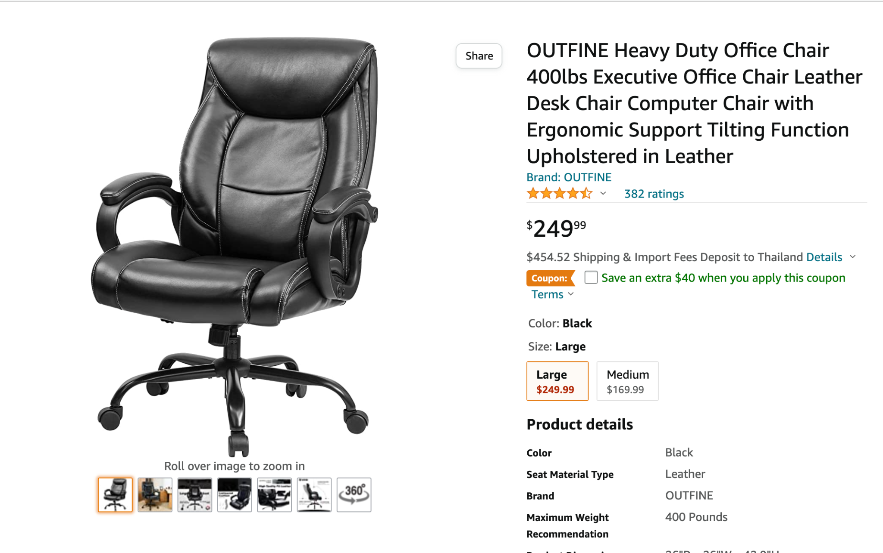

**Product 2**

Source:

https://www.amazon.com/Logitech-C920x-Pro-HD-Webcam/dp/B085TFF7M1/ref=lp_16225007011_1_9?th=1

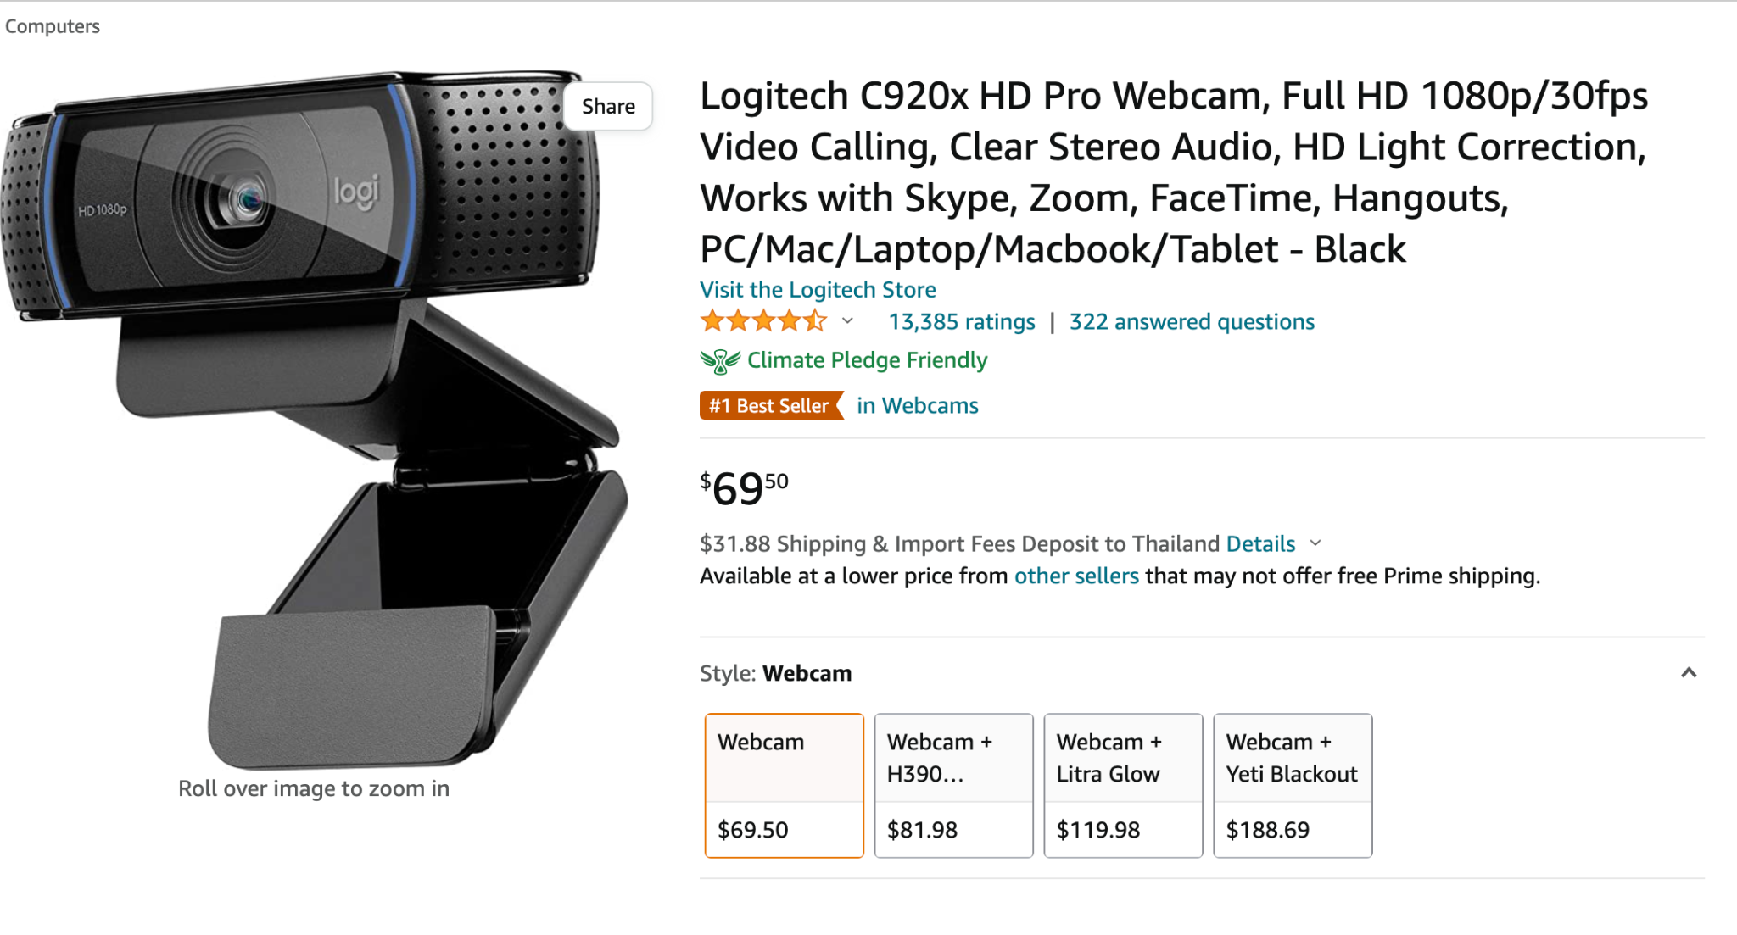

[Show your design here]

{

"id": “numberID”,

"name": "nameItem",

“rate”: [

{

“star” : X,

“ratings”: XX

}

],

“Option” : [

{

“Size”: “X”,

"price": XX.XX

}

],

"product detail": [

{

"Color": "X ",

"Brand": "X",

"Product Dimensions": [

{

"depth": X,

"width": X,

"height": X

}

],

“Material” : “X”,

“Recommended Uses For Product”: ”X”,

“Room Type”: ”X”

}

]

}

{

"id": X,

"name": "X",

“rate”: [

{

“star” : X,

“ratings”: X

}

],

“Option” : [

{

“Product” : “X”,

"price": XX.XX

"product detail": [

{

"Brand": "X",

“Connectivity Technology”,”X”,

"Color": "X",

“Special Feature” : “X”,

“Screen Size” : “X“,

“Photo Sensor Technology” : “X”

}

],

},

]

}

**Task 2:** Insert the above 2 products using MongoDB command.

{

"id": 1,

"name": "OUTFINE Office Chair Executive Office Chair Desk Chair Computer Chair with Ergonomic Support Tilting Function Upholstered in Leather",

“rate”: [

{

“star” : 4.5,

“ratings”: 400

}

],

“Option” : [

{

“Size”: “Large”,

"price": 249.99

},

{

“Size”: “Medium”,

"price": 169.99

}

],

"product detail": [

{

"Color": "Black ",

"Brand": "OUTFINE",

"Product Dimensions": [

{

"depth": 26,

"width": 26,

"height": 42.9

}

],

“Material” : “Faux Leather, Leather”,

“Recommended Uses For Product”: ”Office, Gaming”,

“Room Type”: ”Office”

}

]

}

{

"id": 2,

"name": "Logitech C920x HD Pro Webcam, Full HD 1080p/30fps Video Calling, Clear Stereo Audio, HD Light Correction, Works with Skype, Zoom, FaceTime, Hangouts, PC/Mac/Laptop/Macbook/Tablet - Black",

“rate”: [

{

“star” : 4.5,

“ratings”: 13570

}

],

“Option” : [

{

“Product” : “Webcam”,

"price": 67.95

"product detail": [

{

"Brand": "Logitech",

“Connectivity Technology”,”USB”,

"Color": "Black ",

“Special Feature” : “Low Light”,

“Screen Size” : “2.7 Inches“,

“Photo Sensor Technology” : “CMOS”

}

],

},

{

“Product” : “Webcam + H390 Headset”,

"price": 93.31

"product detail": [

{

"Brand": "Logitech",

“Connectivity Technology”,”USB”,

"Color": "Black ",

“Special Feature” : “Low Light”,

“Model Name” : “C920x“,

“Video Capture Resolution” : “1080p”

}

},

{

“Product” : “Webcam + Litra Glow”,

"price": 129.31

"product detail": [

{

"Brand": "Logitech",

“Special Feature” : “Low Light”,

“Camcorder type”, “Video Camera”,

“Model Name” : “C920x“,

“Video Capture Resolution” : “1080p”,

“Lens Type”: “Zoom”

}

},

{

“Product” : “Webcam + Yeti Blackout”,

"price": 184.71

"product detail": [

{

"Brand": "Logitech",

“Connectivity Technology”,”USB”,

"Color": [ “Blue”, “Black "],

“Special Feature” : “Low Light”,

“Model Name” : “C920x“,

“Video Capture Resolution” : “1080p”

}

},

]

}

**Task 3:** Suppose the TickTock E-Commerce owner would like to maintain the number of product items in the stock, show how you update the above products to store the quantity in the stock. E.g., the default quantity in the stock is 100.

db.product.updateMany({ }, {$set: {stockQuant: 100}})

**Tasks 4 to 7 refer to the data in the MongoDB database in the MongoDB Atlas at the host**

**Task 4:** Write a query to show all products having a price greater than 300, that are made in Thailandshowing all fields except **status**.

db.product.find({price:{$gte:300},’description.countrOfOrigin’:{$eq:’Thailand’}},{status:0})

**Task 5:** Write a query to show the total number of products from the country Maldives grouping them by the order status. (**Hint**: use $lookup)  
Expected Output (show for all three **status**: Delivered, New and Confirmed):

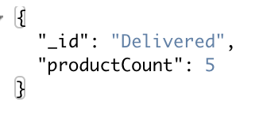

db.order.aggregate([

{ $lookup:

{ from: 'product', localField: 'productId', foreignField: 'id', as: 'productInfo' }

},

{ $match:

{ 'productInfo.description.countrOfOrigin': 'Maldives' }

},

{ $group:

{ _id: '$status', productCount: { $sum: 1 }

}

}

])

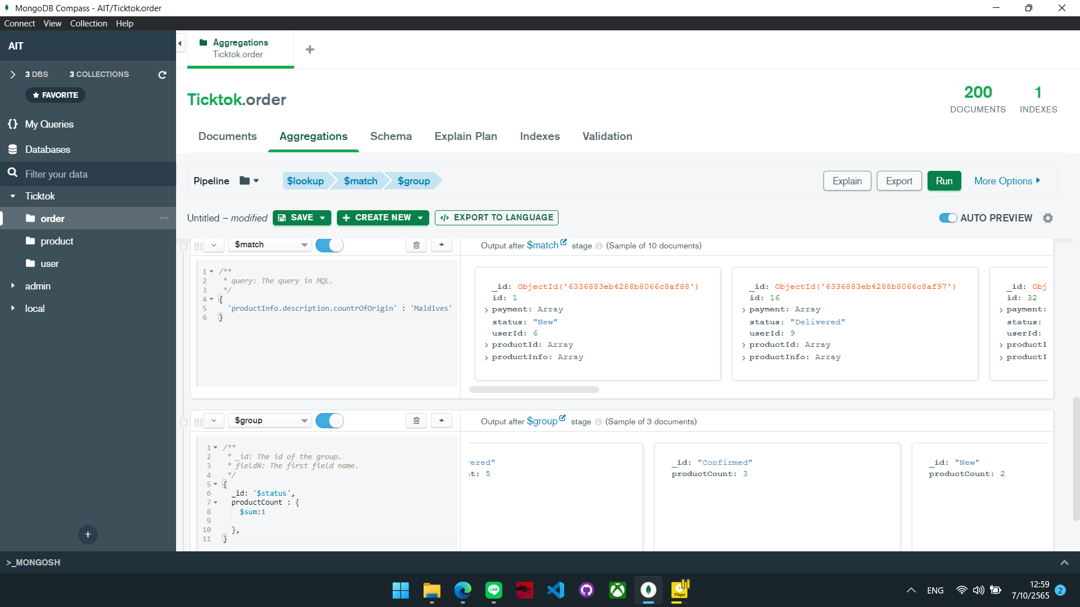

**Task 6:** List all the email addresses of the users whose order has been confirmed but the payment status is Pending and the total payment to be made is more than 5000. (**Hint**: use $project to display: email, payment status, payment total and order status)

db.order.aggregate([

{ $lookup:

{ from: 'user', localField: 'userId', foreignField: 'userId', as: 'userInfo' }

},

{ $match:

{ status: 'Confirmed', 'payment.paymentStatus': 'Pending', 'payment.total': { $gte: 500 } }

},

{ $project:

{ 'userInfo.email': 1, 'payment.paymentStatus': 1, 'payment.total': 1, status: 1 }

}

])

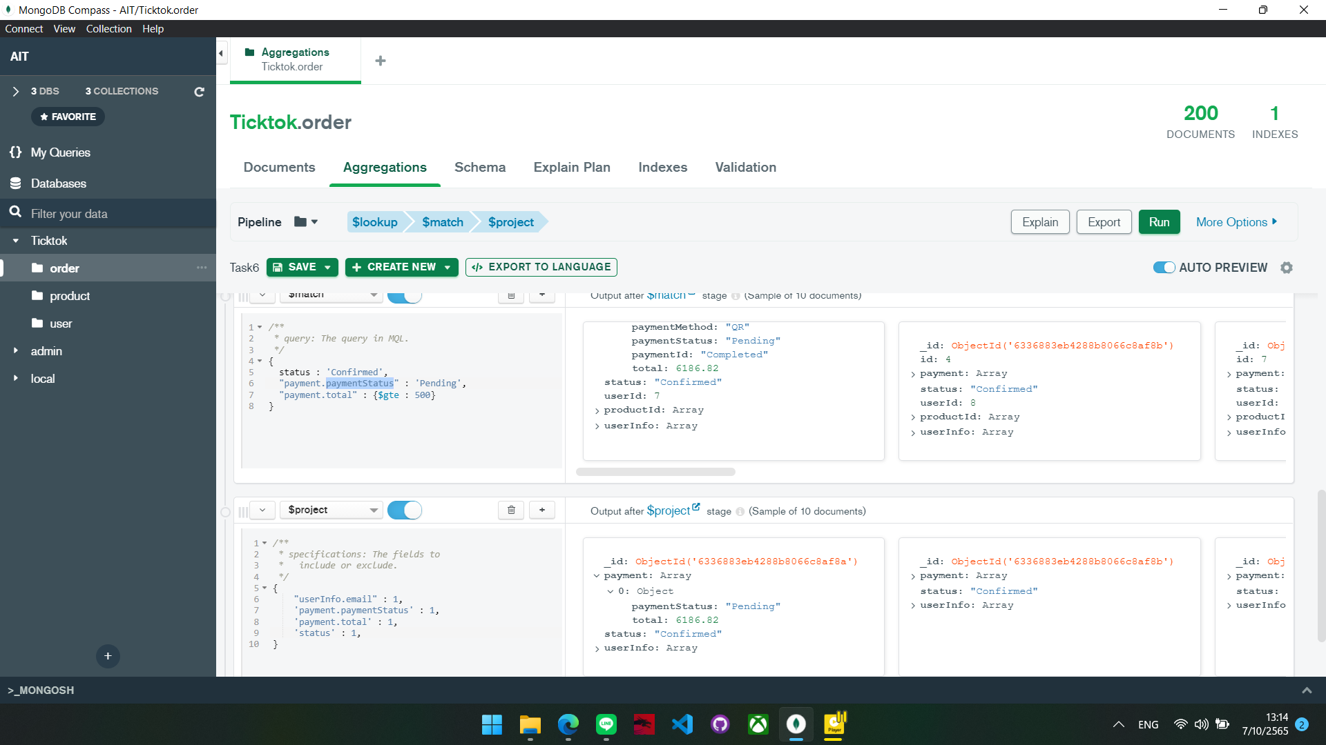

**Task 7:** Modify the above query to show the total number of customers having payment status pending from each country in descending order. Expected Output

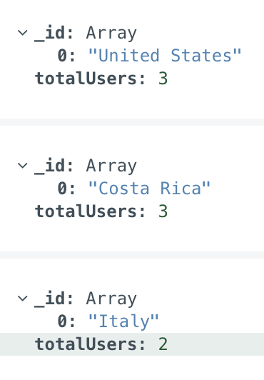

db.order.aggregate([

{ $lookup:

{ from: 'user', localField: 'userId', foreignField: 'userId', as: 'userInfo' }

},

{ $match:

{ status: 'Confirmed', 'payment.paymentStatus': 'Pending', 'payment.total': { $gte: 500 } }

},

{ $group:

{ _id: '$userInfo.country’, totalUsers: { $sum: 1 }

}

])

